

**Superior University Lahore**

Software Engineering Department

Final Project Report

May 21, 2020

Machine Learning: Teachable Machine. with google.com

|  |  |
| --- | --- |
| Name : | Abdul Haseeb Wajid |
| Roll no : | BCSM-S17-001 |
| Submitted to : | Dr. Muhammad Arfan Jaffar |
| Class : | BSSE 7A |

**Abstract**

# How can accessibility research leverage advances in machine learning and artificial intelligence with limited data? In this article, we argue that teachable machines can empower accessibility research by enabling individuals with disabilities to personalize a data-driven assistive technology. By significantly constraining the conditions of the machine learning task to a specific user and their environment, these technologies can achieve higher robustness in real world scenarios. In contrast to automatic personalization, the end user is called to consciously provide training examples and actively interact with the machine learning algorithm to increase its accuracy. We demonstrate this concept with a concrete example: teachable object recognizers trained by and for blind users. Furthermore, we discuss open challenges in designing and building teachable machines with a focus on accessibility.

# **INTRODUCTION:**

Machine learning holds great promise for increasing independent living for people with disabilities. As accessibility researchers, we have embraced its possibilities. We have leveraged advances in natural language processing, speech, and computer vision to create novel assistive technologies, gain a deeper understanding of our users, and detect barriers in their environment. While not an extensive list.

At the heart of all machine learning applications is the need for data. This need becomes even greater as we transition to more complex deep learning architectures that offer state-of-the-art performance. In some cases, accessibility researchers can leverage existing large datasets obtained from a broader population.

**What is Teachable Machine? :**

The Teachable Machine is an effort by Google to make Machine Learning and AI accessible to the wider public, without requiring any specialized training, knowledge in Computer Science or coding.

**How does a teachable machine work? :**

Teachable Machine is a web tool that makes it fast and easy to create machine learning models for your projects, no coding required. Train a computer to recognize your images, sounds, & poses, then export your model for your sites, apps, and more.

**What algorithm does TensorFlow use? :**

Python and Java Script is easy to learn and work with, and provides convenient ways to express how high-level abstractions can be coupled together. Nodes and tensors in TensorFlow are Python objects, and TensorFlow applications are themselves Python applications. The actual math operations, however, are not performed in Python.

# **METHADOLOGY:**

First of all go to the teachable machine website “<https://teachablemachine.withgoogle.com/>”

* And here you click on Get started button.
* Then select your category that you want to make the project.
* I select “Image project”.
* And than you show the next page here you define your classes that you want to make project.
* I make four classes in this project.
* 1)Humans 2)Cats 3)Dogs 4)Horse
* And then select 10/10 images on every class.here I show you the screenshot.
* And when you select samples of every class than you click on train model button and train the classes for machine learning.
* After clicking the button you should wait for some time for training the models.
* After this your sample is being trained and then you test your data or model.
* Here you test your model by chosing diff files of related to yours class.
* Here I choose any dog image random and then show the result.
* Here you see that your model is well trained you choose dog image and the model also show you that this is a dog.
* And after this you download the project and upload it on the github website.
* For uploading the project on git hub you need to create an id on github and download git software.
* At the end of the document I attach the links of this model.

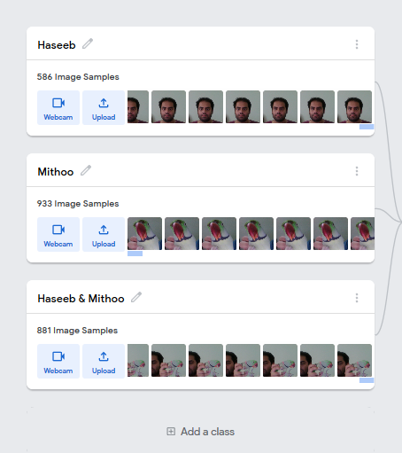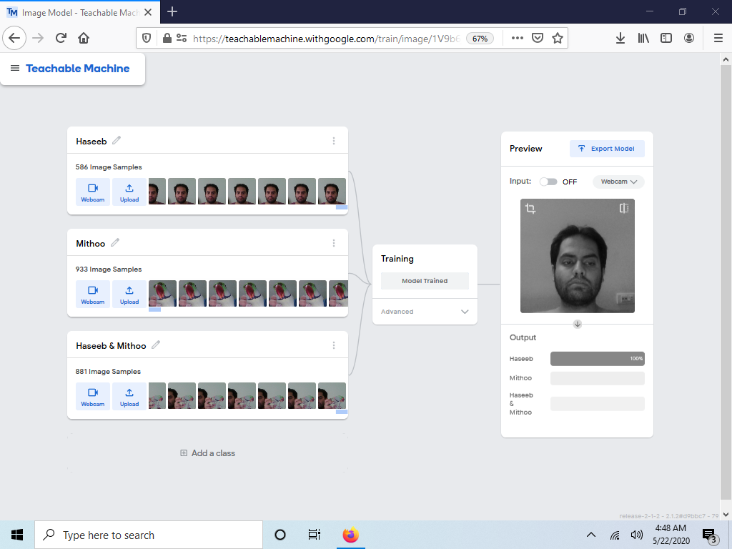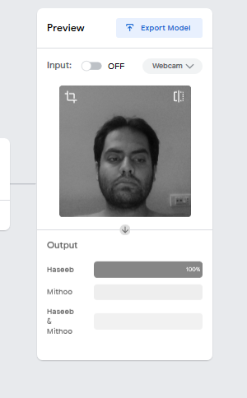

# **CONCULSION:**

The Teachable Machine is a great tool for machine learning. With it we can teach the machine through different type of models like Image Model, Audio Model and Pose Project we could train the machine to differ between the various classes and at the end represent them in a good visual manner.

**Refference :**

Teachable Machine link :

<https://teachablemachine.withgoogle.com/models/CF6Y5t326/>

GitHub link :

https://github.com/haseebwajid87/Teachable-Machine-Data-Science.git